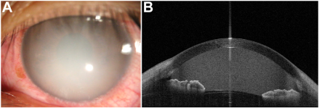

A 31-year-old man presented with left eye redness for 5 days, irritation, and sudden vision loss to finger counting. A, Examinationrevealed creamy white aqueous humor without hypopyon. B, Anterior-segment OCT showed homogenous hyperreflectivity. Despitenegative pathogen tests, he was diagnosed with diabetic ketoacidosis and severe hyperlipidemia (triglycerides 45.66 mmol/l, totalcholesterol 22.33 mmol/l, positive urinary ketones). Urgent insulin and lipid-lowering treatment cleared the lipid-laden aqueous humor in 3days, unveiling aqueous flare and peripheral lipemia retinalis. Disruption of the blood-aqueous barrier from iridocyclitis was hypothesized.The patient was administered dexamethasone eye drops. Visual acuity was restored to 20/20 within 1 week, which supported our hypothesis. Based on the provided images and clinical description please make an ophthalmic diagnosis for this patient. And output the diagnostic conclusions only.

**Lipemic aqueous humor secondary to severe hyperlipidemia and diabetic ketoacidosis, with associated iridocyclitis and lipemia retinalis.**